Data Engineering Project

Group 17

Artjom Smorgulenko, Samuel Pasierb, Shuvojyoti Singha, Kaan Özkilic

Analyzing CompanyLtd data
1. Restored the .bak database and loaded it into CompanyLtd.
2. Created the StagingDatabase using the course file.
3. Imported data from CompanyLtd to StagingDatabase for each table required.
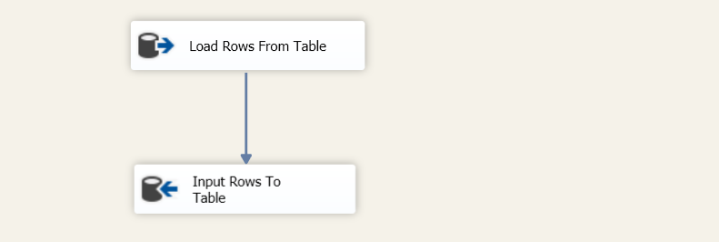

Cleaning stage
Created a dataflow task and added a Flat File Source Assistant for Electricity Price Data (electricity_price.csv).
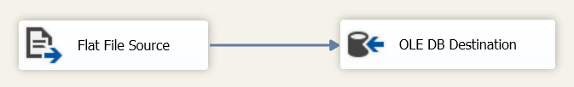
First 2 rows of the source file was skipped for usability.
This SQL script is used to clean the data:
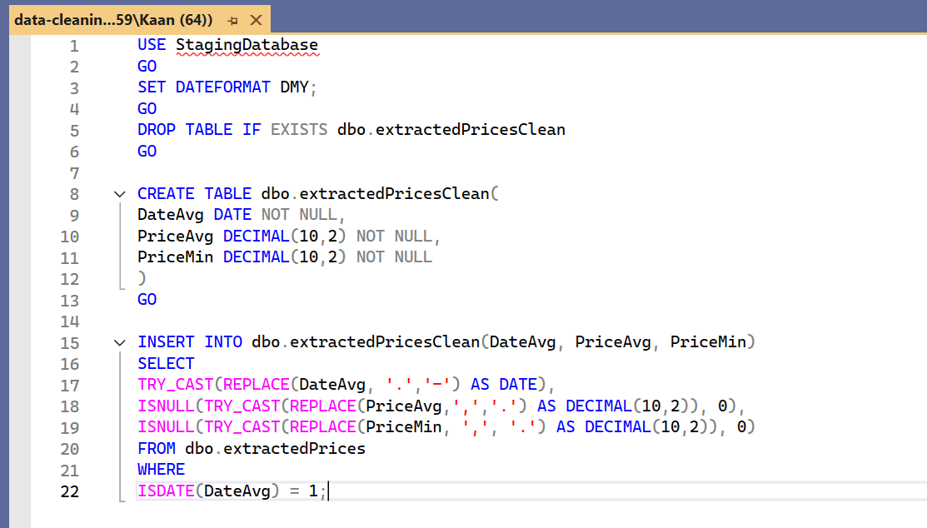
First a table is created for clean and ready data,
then the data is taken from the other table,
and finally the data gathered is cleaned, the dates are formatted and invalid dates are removed.

[DATABASE RELATIONSHIP PIC]

Invoice – contract stuff

Visualization

View 1: How much does each country bring from contacts?
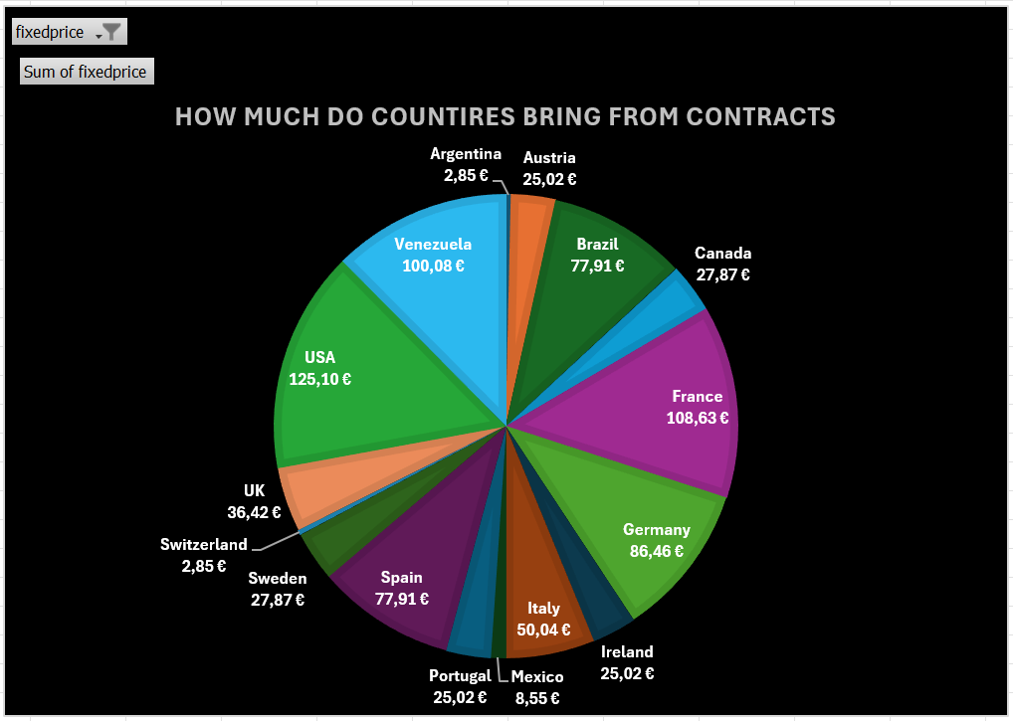
Used SQL view creation script: link

View 2: Monthly Fixed Price
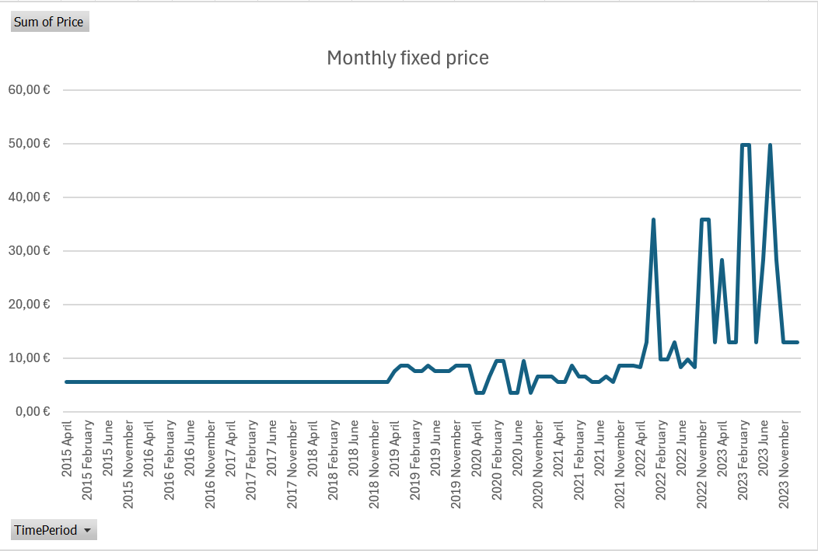
Used SQL view creation script: link

View 3: Average and Minimum Monthly Prices
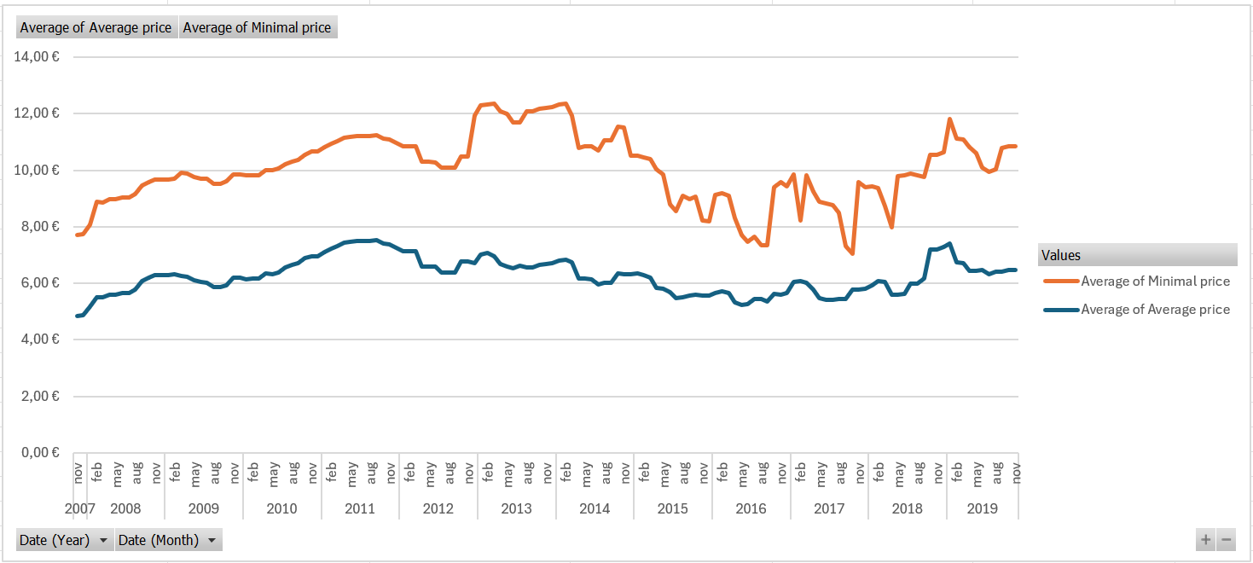
Used SQL view creation script: link

ETL Diagram

Work Distribution

